Grouping Objects

Collections: an introduction
Many applications involve collections of objects:
- Personal organisers
- Library catalogues
- Student-record systems
The number of items to be stored varies. Items are added, items are deleted. We don’t know how many objects we are dealing with.

Class Libraries
Class libraries are a library of useful classes.
- We don’t have to write everything from scratch.
- Java calls its libraries, packages.
- Grouping objects is a recurring requirement.
  - The java.util package contains multiple classes for doing this.

import java.util.[package];

ArrayList

private ArrayList<String> files;

We specify the type of collection and the type of objects it will contain. In English, it’s comparable to saying “ArrayList of String”.

Generic Classes
Collections are known as parametrized or generic types.
- ArrayList implements list functionality:
  - add, get, size, etc.
- The type parameter says what we want a list of:
  - ArrayList<Person>
  - ArrayList<TicketMachine>
  - etc.

Creating an ArrayList object
In versions of Java prior to version 7
- files = new ArrayList<String>();
Java 7 introduced “diamond notation”
- files = new ArrayList<>();
The type parameter can be inferred from the variable being assigned to.
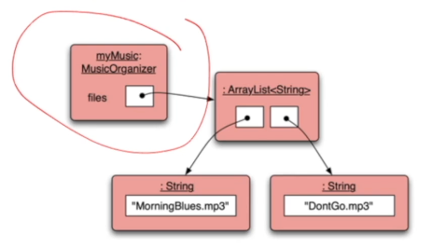

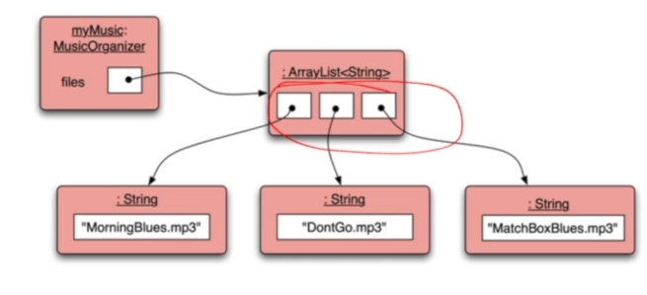
Adding a third file:

Features of the collection:
- It increases its capacity as necessary.
- It keeps a private count
  - .size() accessor
- It keeps the objects in order.
- Details of how all this is done are hidden.
We can use ArrayList with any class type. Each will store multiple objects of the specific type.

Using a collection class

Index Numbering
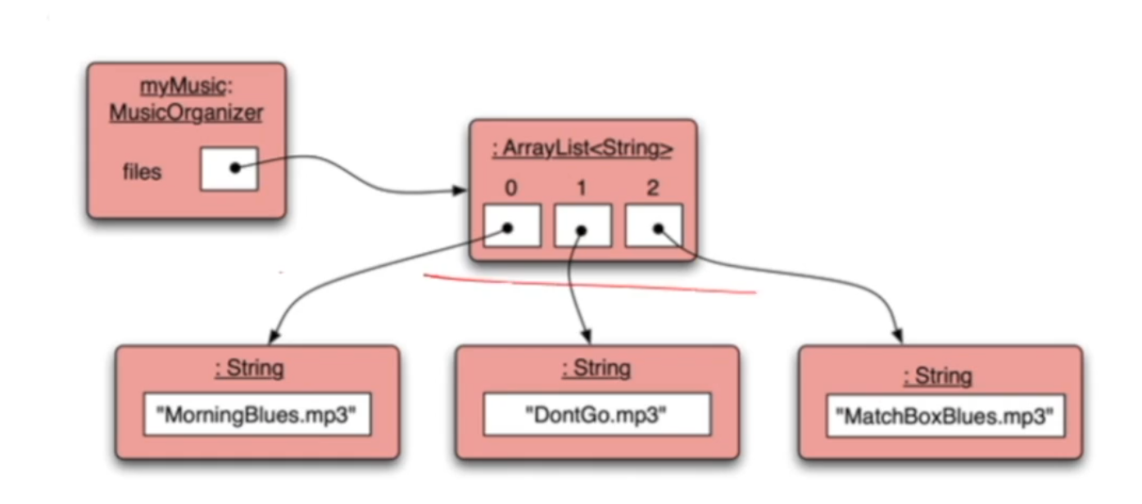
Whenever we are counting, we start at 0.

Retrieving from the collection
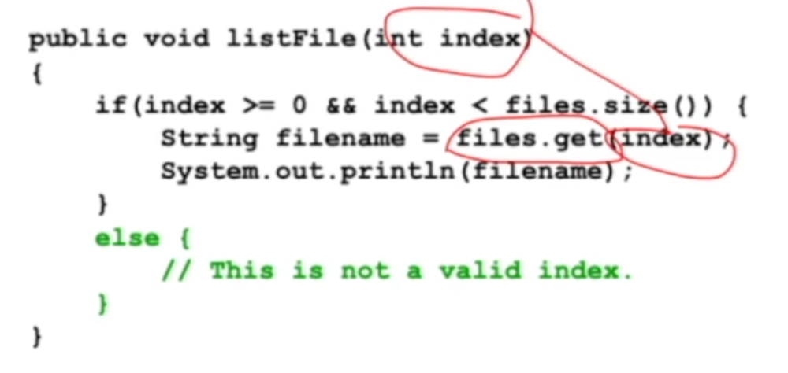

The general utility of indices
Using integers to index collections has a general utility:
- “next” is index + 1
- “previous is index – 1
- “last” is list.size() -1
- “the first three” is: the items at indices 0, 1, 2
We could also think about accessing items in sequence: 0, 1, 2…

Iteration: the for-each loop
The process of repeating some actions over and over.
- Loops provide us with a way to control how many times we repeat these actions.
- With a collection, we often want to repeat the actions exactly once for every object in the collection

